Ch 4 Study Guide
Multiple Choice
Choose the letter that best answers the question or completes the statement.

- Describe nonrenewable energy sources. What is a benefit of this type of energy source?

- List 3 examples of fossil fuels.

- Describe the process in forming petroleum and natural gas.

- Define Hydroelectric power:

- What substance is necessary to fuel nuclear power plants?

- Describe conservation:

- Describe renewable energy sources.

- Which one of the substances listed below is a fossil fuel?

  - Uranium
  - Petroleum
  - carbon dioxide
  - granite

- Describe the relationship between recycling and resource consumption.

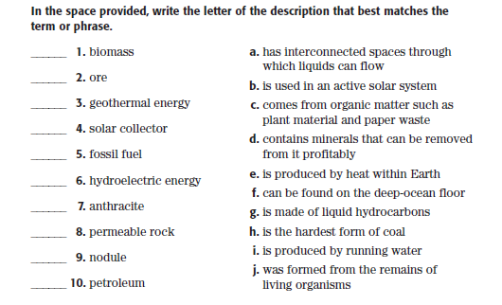

Understanding Concepts

- What is a major negative impact of the use of fossil fuels?

- Why do hydroelectric dams have limited lifetimes?

- What are three things that you can do to prevent water pollution?

- What are three things that you can do to save energy?

Critical Thinking

- What effect can recycling paper have on the use of resources and the creation of pollution?

- How might an increased use of alternate energy sources such as wind and solar radiation affect the lifetime of fossil fuel resources?

- What is the difference between how electricity is produced with tides and how it’s produced in a nuclear power plant?

- The factors in favor of the use of solar power include the fact that the fuel it uses is free, it’s renewable, and it doesn’t create pollution. Identify drawbacks of the use of solar power.

