Ch 4 Study Guide
Multiple Choice
Choose the letter that best answers the question or completes the statement.

- Describe nonrenewable energy sources. What is a benefit of this type of energy source?

Sources that can be replenished in a short period of time. There is not a concern of depleting their availability. Some of these sources typically don’t let of harmful emissions.

- List 3 examples of fossil fuels.
Petroleum, Natural Gas, Coal

- Describe the process in forming petroleum and natural gas.
The remains of plants and animals buried in seas long ago.

- Define Hydroelectric power:

Producing electricity using moving water

- What substance is necessary to fuel nuclear power plants?

Uranium

- Describe conservation:

The careful use of resources

- Describe renewable energy sources.

A source of energy that can be replenished in a short period of time.

- Which one of the substances listed below is a fossil fuel?

  - Uranium
  - Petroleum
  - carbon dioxide
  - granite

- Describe the relationship between recycling and resource consumption.

The more material is recycled, the less amount of a resource will be consumed.

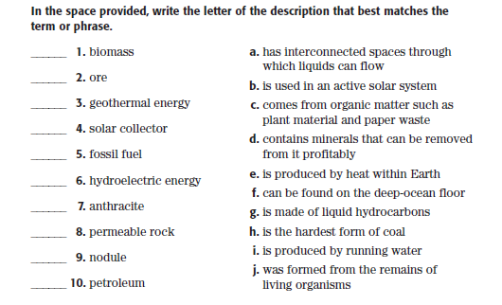

1. c
2. d
3. e
4. b
5. j
6. i
7. h
8. a
9. f
10. g

Understanding Concepts

- What is a major negative impact of the use of fossil fuels?

They are nonrenewable. Many of them emit harmful gasses into the atmosphere

- Why do hydroelectric dams have limited lifetimes?
Water can erode the dams. Water supplies in certain areas can decrease over time

- What are three things that you can do to prevent water pollution?

Don’t pour chemicals and medicines down the drain.
Utilize chemical/oil recycling centers.
Limit the amount of fertilizers, chemicals, and pollutants put onto grasses, crops, and plants.

- What are three things that you can do to save energy?

Turn of lights/reduce the amount of lighting being used
Limit the amount of heating/cooling in your house
Limit fuel use by taking public transportation/sharing rides

Critical Thinking

- What effect can recycling paper have on the use of resources and the creation of pollution?
An increase in recycling can decrease the amount of resources needed to be used and limit the amount of pollution caused during the process of making paper.

- How might an increased use of alternate energy sources such as wind and solar radiation affect the lifetime of fossil fuel resources?
Fossil fuel resources would decrease at a slower rate if alternate energy sources are used at a higher rate.

- What is the difference between how electricity is produced with tides and how it’s produced in a nuclear power plant?

The production of electricity using tides requires a turbine to be moved using moving water. Electricity created in a nuclear power plant is created by utilizing uranium and splitting atoms to create a source of heat.

- The factors in favor of the use of solar power include the fact that the fuel it uses is free, it’s renewable, and it doesn’t create pollution. Identify drawbacks of the use of solar power.

Solar power systems require a large area needed to place the solar paneling. This needed area could negatively impact ecosystems nearby.

