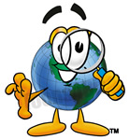
Name: ______Answer Key_____________________________________ Period: _______ Due Date: _______

Ch. 1 Intro to Earth Science Study Guide
Vocabulary

1.1 What Is Earth Science?
Earth science, p. 2; geology, p. 2; oceanography,
p. 3; meteorology, p. 3; astronomy, p. 3

1.2 A View of Earth
hydrosphere, p. 7 atmosphere, p. 7; geosphere, p. 7;
biosphere, p. 7; core, p. 8; mantle, p. 8; crust, p. 8

1.3 Representing Earth’s Surface
latitude, p. 11; longitude, p. 11; topographic map,
p. 14; contour line, p. 14; contour interval, p. 14

1.4 Earth System Science
system, p. 18

1.5 What Is Scientific Inquiry?
hypothesis, p. 23; theory, p. 2

 |  | Never | Sometimes | Usually | Always
 | I maintained a positive attitude
 | I stayed focused and alert during class
 | I asked questions when I was confused
 | I participated in classroom discussion and answered questions
 | I completed and turned in work from class
 | I complete and look over my bellringers
 | I concentrated on taking good notes to help me review
 | I took my notebook home to study for the test
CHAPTER
Reviewing Content
Choose the letter that best answers the question or completes the statement.

- The science that deals with the study of the atmosphere is

  - oceanography.
  - meteorology.
  - geology.
  - astronomy.

- Lines of latitude describe position
  - north or south of the equator.
  - east or west of the equator.
  - north or south of the prime meridian.
  - east or west of the prime meridian.

- The Robinson map projection is considered very useful because
  - all of the continents are the same size.
  - most distances, sizes, and shapes are accurate.
  - it shows landmasses in three dimensions.
  - features along latitude lines are accurate.

- Which of the following maps shows the three dimensions of Earth’s surface?

  - Mercator projection
  - Topographic
  - Gnomonic
  - Conic

- What makes a hypothesis scientifically useful?
  - Many people think it is a good idea.
  - It can be tested.
  - It contains numerical data.
  - It applies directly to Earth science.

- On a topographic map, contour lines that are closer together indicate

  - forest.
  - a steeper slope.
  - a mountain top.
  - roads.

- The _____ strongly influences the other three “spheres” because without life their makeup and nature would be much different.

  - Atmosphere
  - Hydrosphere
  - Geosphere
  - Biosphere

- The science that includes the study of the composition and movements of water, as well as coastal processes, the seafloor, and marine life is ________.

  - Geology
  - Oceanography
  - Meteorology
  - Astronomy

Understanding Concepts

- Which of Earth’s spheres do the following represent?

  - Mountains: Geosphere
  - Lakes: hydrosphere
  - Trees: Biosphere
  - Clouds: Atmosphere
  - Ice: Hydrosphere
  - Snow: Hydrosphere
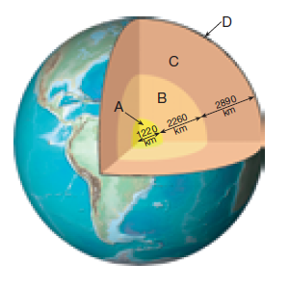
- List the three parts of the geosphere indicated at the letters in the figure.
  - ______Inner Core___________________
  - ______Outer Core___________________
  - ______Mantle___________________
  - ______Crust___________________

- What are Conic projections used for? Weather and Road Maps

- Why is the contour interval important to know on a topographic map? So you know the elevation.

- What are the two sources of energy for the Earth system? Sun and core of Earth

- What is the first step to the scientific method? Find a problem

Critical Thinking

- How is a scientific hypothesis different from a scientific theory? Hypothesis is an educated guess, while a theory is well accepted and backed by data

- Explain the following statement: If Earth had no atmosphere, our planet would be lifeless. No oxygen to breath, no carbon dioxide for plants, and intense solar radiation would kill everything.
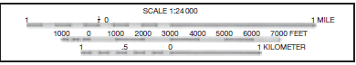
Use the bar graph to answer Questions17.
- Approximately how many miles is 1 kilometer equal to?
1 km = .6 miles

Map Skills
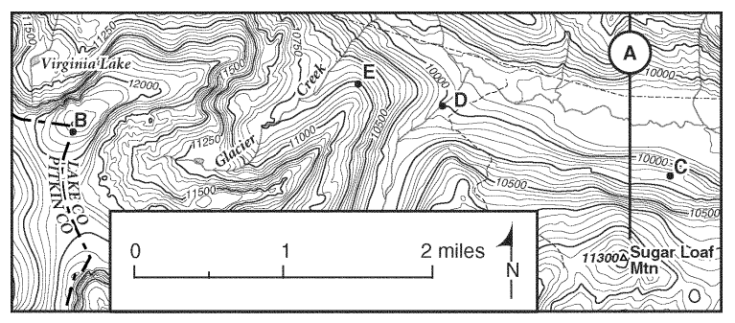
Use the map to answer questions 18 and 19.

- How far is it in miles from point B to point E?
2 miles

- What is the elevation of Sugar Loaf Mountain?
11300 feet

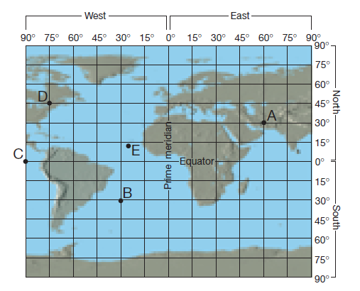
Use the map to answer questions below

- What is the latitude and longitude for point A on the map?
.F
30˚N, 60˚E

- Locate the state of Florida on the map.
What is the approximate location of its southernmost point?
25˚N, 82˚W

- Which lines run east and west? Latitude

- Compare and Contrast point B to point F.
Same longitude 30˚W different latitude

